Some notes…

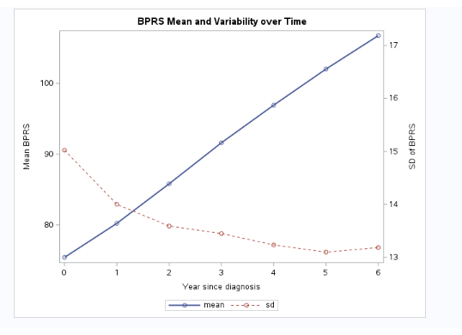

The figure suggests that BPRS increases roughly linearly over time while between-subject variability decreases.
This pattern is consistent with progressive worsening of psychiatric symptoms and a possible convergence among patients in later disease stages.
Statistically, it signals non-constant variance — a key consideration for selecting the covariance structure in your mixed model.
• Don’t assume homogeneous variance (constant across time).
→ Instead, test covariance types like:
- CSH (compound symmetry, heterogeneous)
- ARH(1) (autoregressive, heterogeneous)
- TOEPH (Toeplitz, heterogeneous)
• Consider including time as a continuous variable (linear) initially, since the trend looks very regular.
• Later, test if the slope differs by residence (WZC) or sex, since group effects might change the shape or level of the trend.
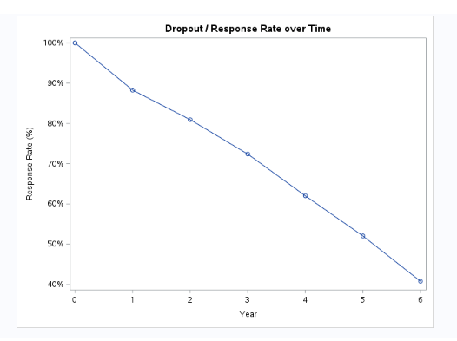

Over six years, the study retains about 40% of its participants.
Dropout increases steadily over time, most likely due to disease progression and related difficulties in follow-up.
This progressive loss of participants reduces sample size and may introduce bias if the dropout depends on patient condition.
Hence, modeling approaches that assume data are Missing At Random (e.g., mixed-effects models with REML) are appropriate, and the missingness mechanism should later be examined explicitly.

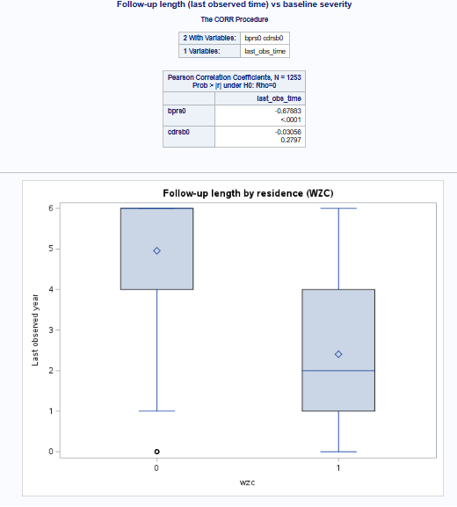
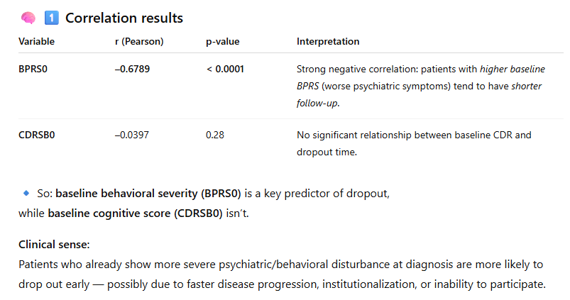
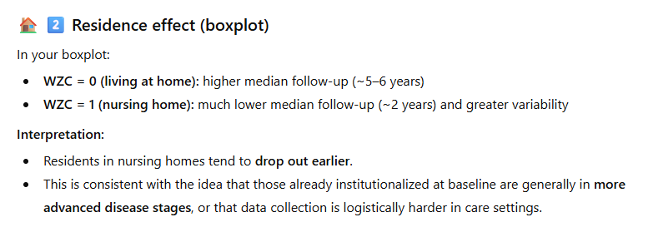

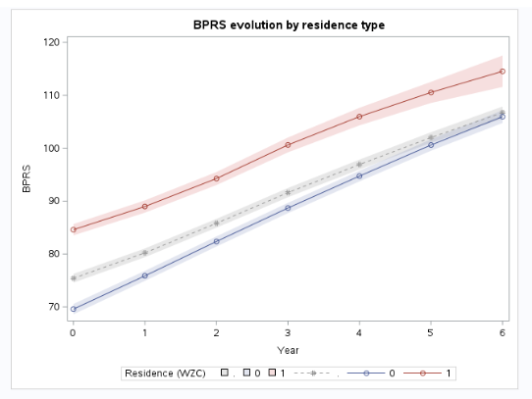

Patients residing in nursing homes start out with more severe psychiatric symptoms and maintain that higher severity across the 6-year follow-up.
Both groups show a steady, roughly linear increase in BPRS, consistent with progressive behavioral decline.
The overall pattern supports including WZC as a covariate in the mean structure of the mixed model and possibly exploring a Time × WZC interaction to confirm that the slopes truly remain parallel.

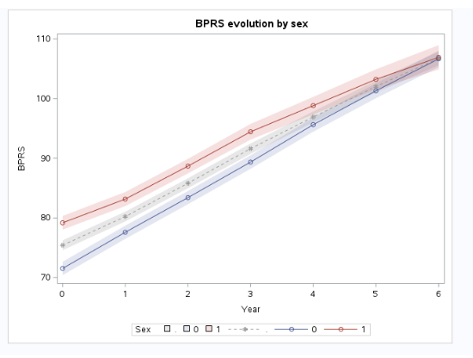
Both male and female Alzheimer’s patients experience a similar linear increase in behavioral symptom severity (BPRS) over the six-year follow-up.
Female patients tend to start and remain at a slightly higher level of symptoms, but the rate of progression is comparable between sexes.
Statistically, this supports including Sex as a covariate in the model to account for overall level differences, while a Time × Sex interaction is probably unnecessary unless later tests show otherwise.

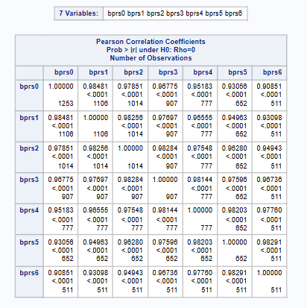

The repeated BPRS measurements are strongly correlated over time, especially between adjacent years.
The correlation weakens gradually as the time gap increases, reflecting the natural persistence of behavioral symptoms with slow temporal change.
This pattern supports modeling the covariance using an autoregressive structure (AR(1)), allowing correlation to decline with increasing time separation.

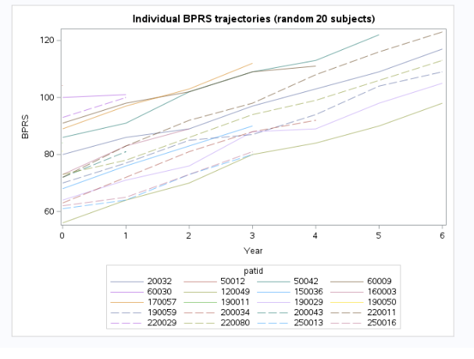
Each line represents a single patient’s behavioral trajectory.
Most patients show a steady, monotonic increase in BPRS over time, confirming progressive worsening.
However, the rate and severity vary widely across individuals, reflecting strong heterogeneity in disease course.
This variation underscores the need for a random-effects model that captures both individual starting points and progression rates.
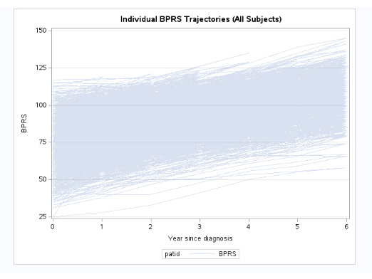

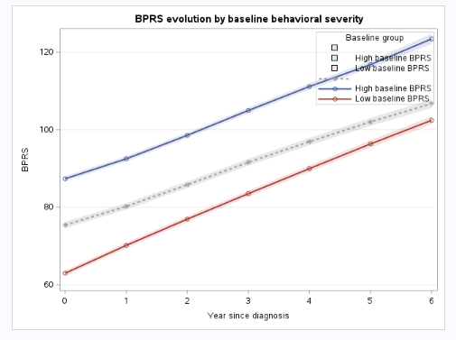

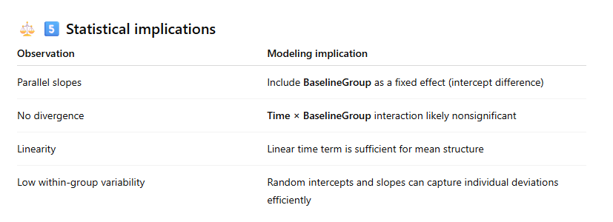
Patients with high baseline behavioral severity remain consistently worse over time, following a trajectory parallel to those with initially milder symptoms.
Both groups show a clear linear increase in BPRS, reflecting steady worsening.
This pattern implies that baseline behavioral severity affects the level of symptoms but not the speed of progression, supporting a model with a group-level intercept difference and a shared slope for time.

